1. Define the following terms:

• Tuple:A tuple is an instance of a relation, represented as a row in a table. It follows that a tuple is an ordered set of attribute values

• Attribute :An *attribute* is one of the properties that define a relation, represented as the name of a column in a table.

• Record: In a database, a record is a group of fields within a table that are relevant to a specific entity.

• Simple attribute:A *simple attribute* has one distinct value per record/row/tuple

• Row:it represents a complete record of specific item data, holds different data within the same structure.

• Multi-valued attribute:A *multi-valued attribute* can have more than one value at a time.

• Composite attribute:A *composite attribute* is composed of multiple sub-attributes.

• Domain:A *domain* is a set of atomic (indivisible) values.

• Primary key:Each tuple/row/record has an attribute that identifies it in a unique manner and that attribute is called the *primary key.*

• Foreign key :A foreign key is a column, or set of columns, that links each row in the child table containing the foreign key to the row of the parent table containing the matching candidate key value.

2. For each of the following situations:

• Identify the relations (entities)

1:Person and enterprise are two entities.

2:Student and Language are two entities.

3:Company and Employee are two entities.

4:Order and product are two entities.

• Draw an E-R diagram that represents the situation.

Sol:

1:

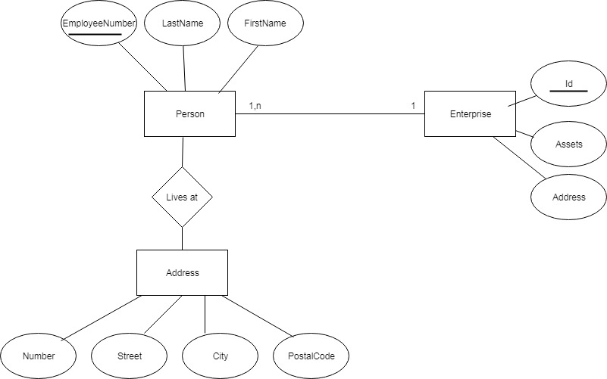

2:

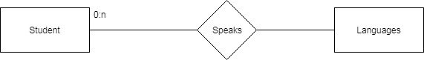

3:

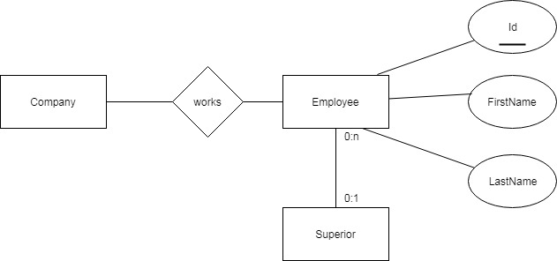

4:

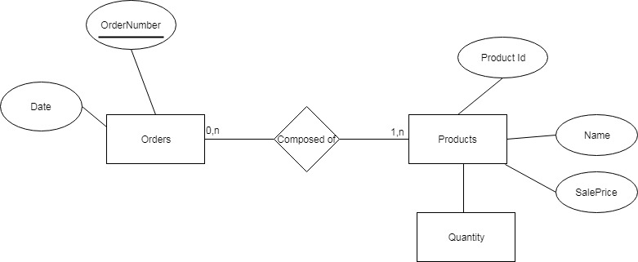

3. A recruitment agency wants to create a database to store and manage CVs. To build this database, the following items have been identified:

